Unit 5/Surface Processes/Agents of Erosion/Miss Cohn
Name:_________________________________________ Block:_______________ Date:__________

Erosion: _________________________________________________________________________________
The forces/materials that transport sediments over time are:
- ____________________ 2. ___________________ 3._____________________

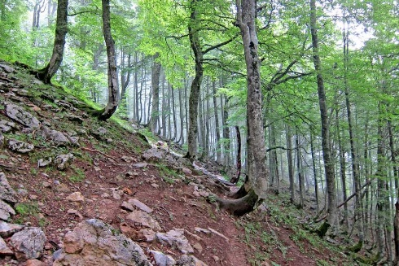
4. ____________________ 5. ___________________

GRAVITY: When __________________________ __________is greater than the force of friction of the land, ______________________occurs!
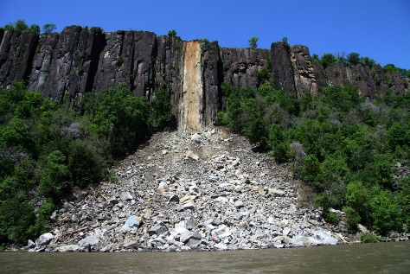
These are called: _________________________ _____________________
Examples include: Soil creep (slow), Avalanches, Landslides, Mudslides, Rock falls and slides *Landslides and mudslides are more prevalent in areas that get heavy amounts of rainfall where the water does not have enough time to infiltrate.
Mass movements can occur do to ___________________________.
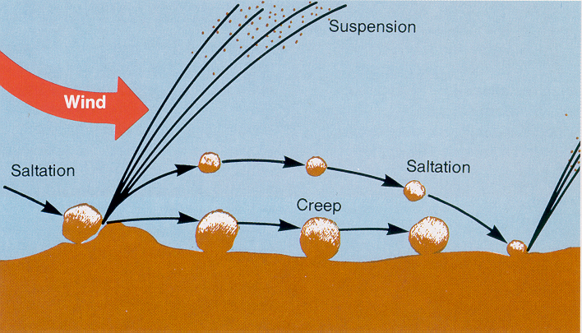
WIND: Wind Erosion is dependent upon _____________
_____________________ and the size of the sediment.
As sediment size ___________________ the amount of erosion by wind will _________________, because more sediment can be carried.
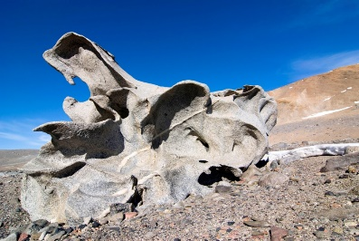
Wind erosion is common in ____________ climates. Mushroom rocks, Ventifacts (bottom right) and sand dunes are all the result of weathering and erosion due to wind.
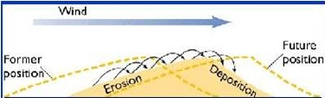
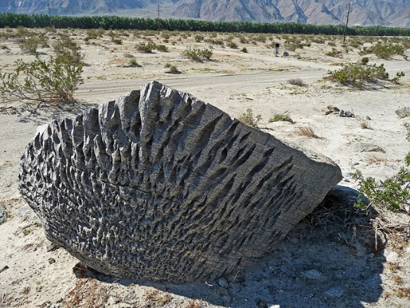

WATER: Streams and Rivers are always carrying sediments of varied sizes.
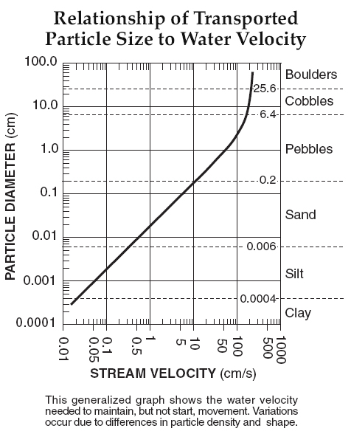
- Small Particles can be____________________, larger particles bounce along the stream bed (___________________), even larger Particles are rolled (_______________)
- The __________________the velocity of a stream, the ________________ sized particle it can carry (erode). Below this speed, _______________ will occur.
This is illustrated on page ___________ of the ESRT.
The following are sediments of increasing sediment size:
Clay, silt, sand, pebbles, cobbles and boulders.

Checkpoint Questions:
- A stream moves at a velocity of 10 cm/s, what sized sediments will erode? _____________________________
- If a stream was traveling at a velocity of 100 cm/s and dropped to a velocity of 10 cm/s due to a decline in rainfall, what sized sediment would become deposited? ______________.
- What stream velocity is needed to carry (erode) a cobble sized sediment? ___________________
- What is the range of size for a sand sized sediment? ____________________ . A clay sized sediment? ___________________?. A boulder is considered anything over _______________ cm in diameter.
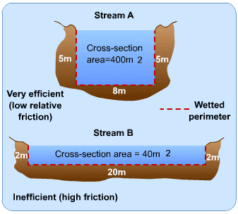
Stream Velocity is dependent on:
- Slope of the Land:

- Volume of Water in a Stream/River:

- Channel Shape and Area:

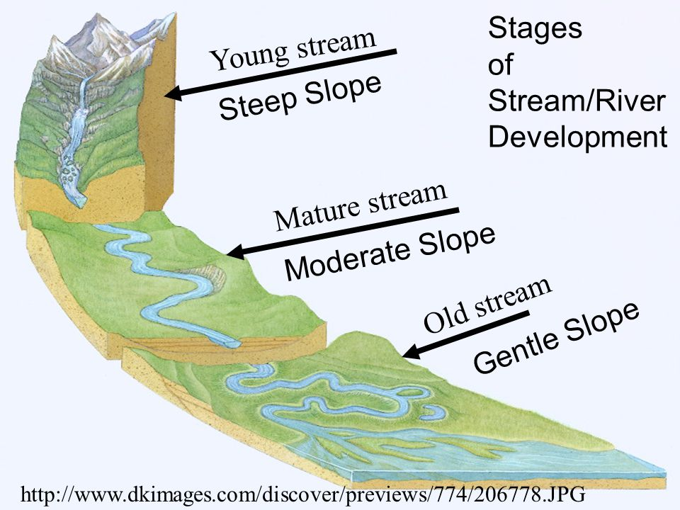
The Young Stream (High Altitude): Water flows fastest in the __________________ and just below the ___________ of the stream if the stream is straight. Erosion will create a ___ shaped valley.
The Old Stream (Flat Landscape): The____________________ a stream is, the more S-shaped curves it develops, called _______________________.
- Because of variations in __________________________, there is deposition & erosion in different areas along a river. This means river profiles differ according to the velocity
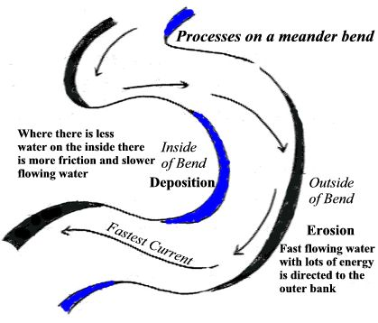
Profile Depth:

1.)__________________ water swings to the outside of the bend causing _________________
2.)___________________ water stays inside the bend causing _______________________.
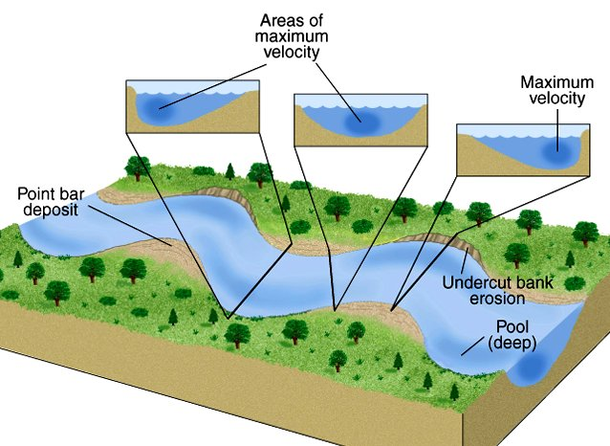
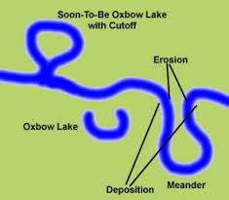
Real world: How could this influence your decision to purchase a home, or a business that was located along an old river system?

Formation of Oxbow Lakes:
__________________by the river eventually cuts a new path for water to flow leaving behind an ________________________, pictured right.
GLACIAL ICE
- A glacier is a ______________ _____________ of slowly moving ice that forms from the_____________________ of snow over time under the ___________________ of its own weight.
Where? Occur in the _____________________ and at ______________________________
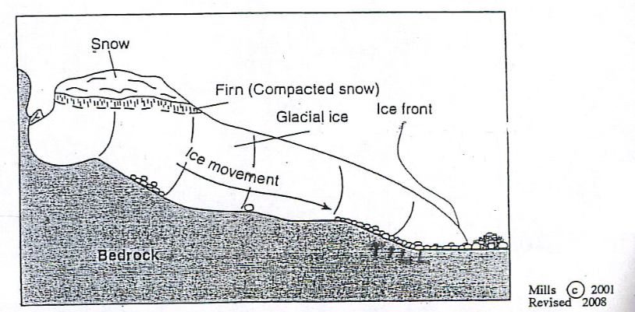
- When glaciers form in a mountain valley, they move _______________________ under the force of gravity, and fastest in the _________________, just like a young stream. As the glacier moves, it plucks up sediments (called till) as it scrapes the land beneath.
A ____________________________ is rock and sediment debris pushed along the edges of a glacier.
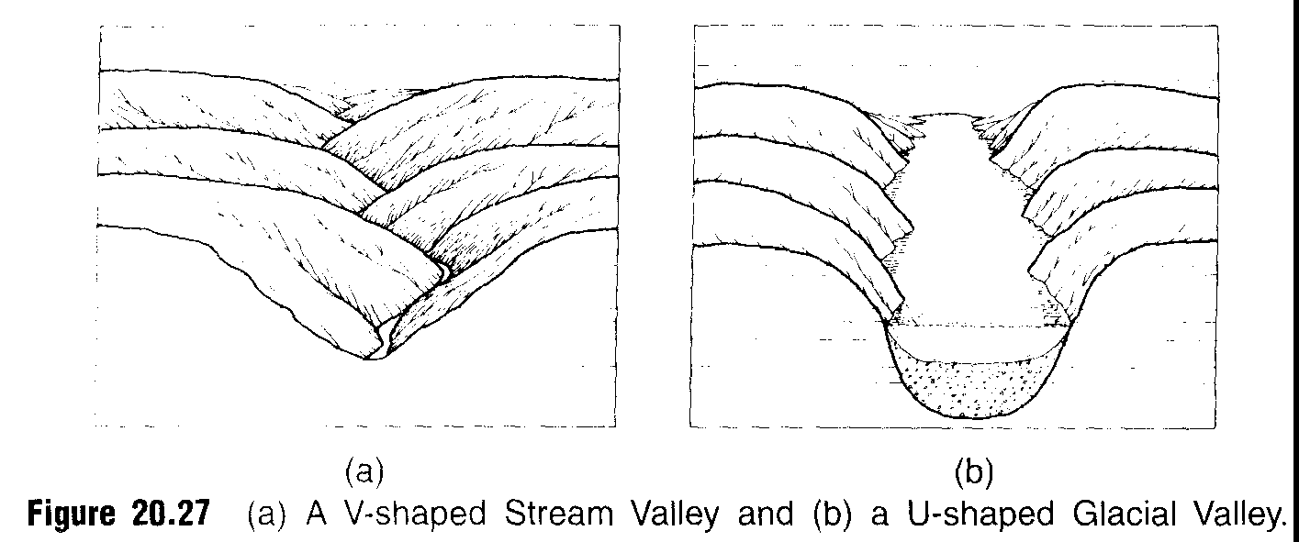
C. Glacial Erosion: A difference between stream erosion and glacial erosion is the shape of the valley
Stream Erosion: ____-shaped
Glacial Erosion: _____-shaped
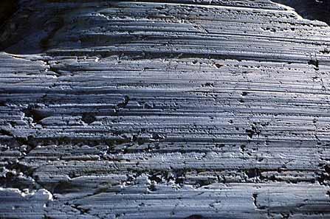
Other Erosional Features from Glacial Ice:
_______________________: parallel lines in the bedrock caused by rock fragments scratching the rocks surface.
_________________________: long thin lakes created by the deepening of pre- existing river valleys in western NY as the ice moved over this area. (Glacial sediment eventually dammed the lakes).
Ocean Currents and Waves
- Surface ocean currents and waves are generated mostly by ________________.
- Wave action: ________________ motion within a wave results in the movement of sediments.
- As waves crash into the shoreline, they erode the bedrock forming_____________ like structures as well as ___________________.
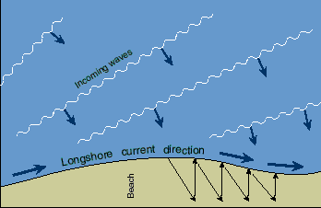
- Sand is constantly eroding along a shoreline, we build _________________________ to limit beach erosion over time
- As waves crash into the shore at an angle, they carry sediment back out to the sea and transport it parallel to the shoreline. This is known as _________________________________.
